## New vaccines that aim to prevent cancer: Starting the conversation

## St Anne’s College, Oxford, Monday 2nd June 2025

### Background

We are in an exciting era for cancer prevention. In Oxford and elsewhere, research scientists are working on the development of vaccines that might prevent the development of cancer in people with a range of conditions that put them at higher risk of cancer.

This research might lead to a future where people are offered a vaccine to prevent the development of common cancers.

At the same time, public awareness and discussion around vaccines have been heightened by the rise in vaccine hesitancy and the reach of vaccine misinformation. Many people refuse even well-established vaccinations for preventable diseases such as measles.

[OxCODE](https://www.oxcode.ox.ac.uk/) and the [Centre for Personalised Medicine](https://cpm.ox.ac.uk/), together with the [Oxford Cancer Cancer Vaccines](https://www.cancer.ox.ac.uk/research/networks/OCVH) PPI Panel, designed an event to start the conversation about vaccines for preventing cancer. We wanted to bring together academics, clinicians, members of the public, and other key stakeholders to explore the possibilities and challenges of this exciting new era for cancer research.

## The event

The team invited a panel of national leaders and patient representatives to convene for an afternoon of talks and discussion. 80 people travelled to St Anne’s College in central Oxford on the afternoon of the 2nd of June, 2025. Delegates included 20 patients, carers and members of the public who travelled from across England to join the conversation.

The programme was designed to combine presentations from expert stakeholders with panel discussions and questions from the delegates.

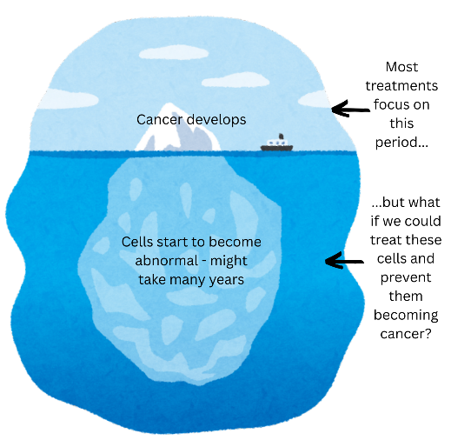The afternoon began with [Professor Sarah Blagden](https://www.oncology.ox.ac.uk/team/sarah-blagden) who gave an accessible introduction to the research and it’s focus on the changes that happen to cells years before cancer is detected.

Professor [Sir Andrew Pollard](https://www.ovg.ox.ac.uk/team/sir-andrew-pollard) joined Professor Blagden and CPM Director, Professor [Anneke Lucassen](https://www.ndm.ox.ac.uk/team/anneke-lucassen), to reflect on learnings from vaccinations programmes for infectious disease and how they might be applied to cancer prevention.

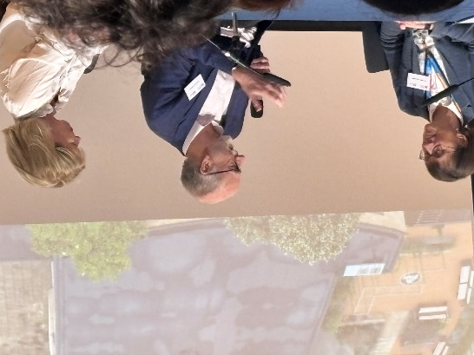Professor [Samantha Vanderslott](https://samanthavanderslott.com/) spoke from the perspective of the social sciences and her work on public attitudes, vaccines hesitancy and vaccines misinformation. Dr Gillian Rosenberg shared her experience of the [National Cancer Vaccines Launch Pad](https://www.england.nhs.uk/cancer/nhs-cancer-vaccine-launch-pad/), which has enabled research on vaccinations given as part of a cancer treatment programme.

Panel discussion with Professors Anneke Lucassen, Sir Andrew Pollard, and Sarah Blagden

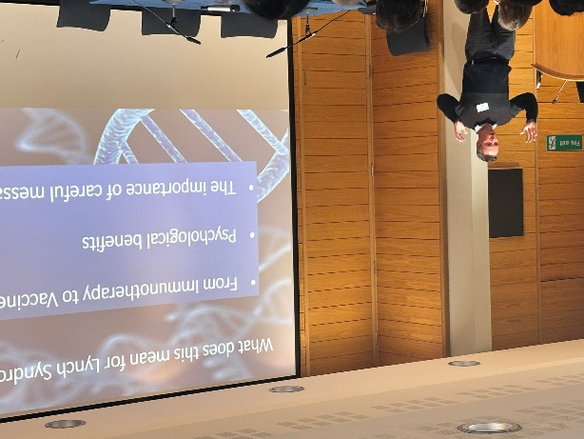Mr Tom Bartlett spoke from the perspective of someone with Lynch Syndrome (LS), an inherited disorder that leads to a significant increase in cancer risk; a vaccination to prevent cancer in people with LS will begin clinical trials in 2026. And Mr Rashmi Kumar spoke from his long experience of community engagement about how all stakeholders need to work together to understand and overcome obstacles and barriers to inclusion.

There was plenty of stimulating and lively discussion, with questions and contributions from multiple perspectives. People with experience of cancer and members of the public very successfully kept the conversations grounded in the communities that the research will serve, and many stated how welcoming, respectful and enjoyable the day was for those who do not have academic backgrounds.

Mr Tom Barlett giving a patient and family perspective

“It felt like a very collaborative space where all questions/opinions mattered”

### “I felt that patients and researchers were respecting and *helping* each other - true collaboration and co-production - well done!”

“[I liked that the event] aimed at understanding how to enable all people to benefit, giving particular attention to reaching out to those who might otherwise miss the opportunities: the "under-served" communities”

## Discussion points and Next steps

In terms of initiating a conversation, there appeared to be consensus on the following:

* We need to maintain collaboration between different stakeholders and areas of expertise – collaborative working will be integral to success.
* Researchers were encouraged to be bold – make clear statements about the benefits of vaccination and not to be reticent.
* Don’t be afraid to call it a vaccine – there is a risk of cultivating mistrust if the language used within the scientific community is different to the language used on public platforms.
* The high visibility of the anti-vax narrative in the online world – and the invisibility of any groups that promote vaccinations – means the anti-vax messaging is disproportionately represented and might be overstated.
* We agreed on the importance of the patients’ voices as advocates for this research. Patients’ voices and stories are trusted, impassioned, and difficult to ignore.
* With this in mind, we should work to equip people with short, punchy, factual responses to post online in response to negative messaging about vaccinations.
* Researchers are encouraged to think of exclusions and barriers that are physical in addition to historic and cultural – time, place, location of activities and research. We need to make it easy to hear from people.
* People seek clarity of messaging but also information in different formats, multiple languages, and in strategic locations online and shared within communities.
* The session gave everyone a strong sense of the potential of community and patient stakeholders to drive and support researchers’ efforts to engage and communicate.
* The Cancer Vaccines PPI Panel will meet to share views on what activity needs to be co-ordinated over the coming months.
* Recordings of the talks will be made available on the CPM YouTube page [here](https://www.youtube.com/@CPMOxford/featured).