SCOPE Data Index Document

Authors
Name | Affiliation
Michael Youdell | Oxford University
Andrew Blake | Oxford University

SUMMARY

This document summarises the data available for secondary analysis that was accumulated from the SCOPE trial.

Table of Contents
1 Study Overview 2
2 Study Design 2
3 Trial Outcomes 3
4 Data Available for Use 4
5 Participant Information 5
6 Data QC 6
7 References 7

List of Figures
Figure 1 – Study Design 2
Figure 2 – Study Outcomes 3

List of Tables
Table 1 - Participant Information Summary 5
Table 2 - Example of QC results ……………………………………………………………………………………………6

Study Overview

Definitive chemoradiotherapy (CRT) is an alternative to surgery for the curative treatment of oesophageal carcinoma. The SCOPE1 trial aimed to investigate the addition of cetuximab to cisplatin and fluoropyrimidine-based definitive CRT in patients with localised oesophageal squamous-cell cancer and adenocarcinomas to assess activity, safety, and feasibility of use.
Patients in the trial had non-metastatic, histologically confirmed carcinoma of the oesophagus (adenocarcinoma, squamous-cell, or undifferentiated; WHO status 0–1; stage I–III disease) and had been selected to receive definitive CRT. Patients were assigned 1:1 to receive CRT alone or CRT with cetuximab for four cycles.

The primary endpoints were the proportion of patients who were treatment failure-free at week 24 and overall survival.

258 patients were recruited, recruitment was stopped because the trial met criteria for futility: Fewer patients were treatment failure free at 24 weeks in the CRT plus cetuximab group than in the CRT only group. The CRT plus cetuximab group also had shorter median overall survival as well as grade 3 or 4 toxicity.

Study Design

All patients received radical chemotherapy for oesophageal cancer. Patients were then randomly assigned to 2 groups:
- Used as control (50% of patients) [129]
- Treated with cetuximab, (an EGFR inhibitor) (50% of patients) [129]

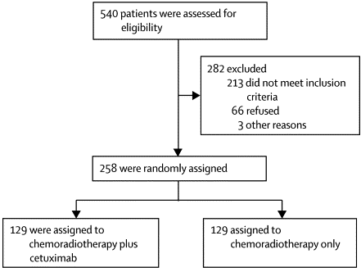
Figure 1 – Study Design

Trial Outcomes

The addition of cetuximab to chemoradiotherapy resulted in more toxicity, less protocol treatment being delivered, and worse overall survival than with chemoradiotherapy alone, although quality of life was not reduced compared with chemoradiotherapy alone. This effect on overall survival was consistent across predetermined subgroups—i.e. histological subtype, tumour stage, and the reason for not undergoing surgery.

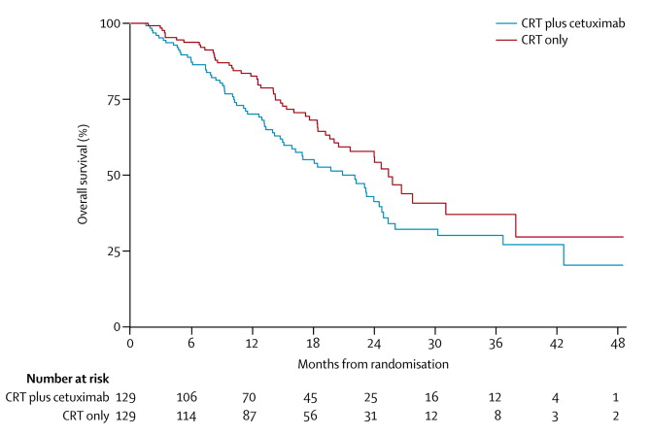

Figure 2 – Study Outcomes

Data Available for Use
The data Available for use in this cohort include:
- Clinical Data (see Section 7)
  - Participant demographics
  - Diagnostic details
  - Outcome
- RNA sequencing data
  - Bulk RNASeq of oesophageal biopsies
  - 3’RNASeq with OligodT (NextSeq 75bp PE, ~100 million reads) using the Welcome Trust Centre for Human Genetics Core Facility on a NovaSeq 6000 platform
  - 172 RNAseq samples, 153 pre and 19 post-therapy (12 weeks after)

Participant Information
Field | Notes
Participant Summary
Age
Gender
Height
Weight
Tumour characteristics
Primary Stage Tumour
Tumour
Site of predominant tumour
Tumour type
WHO performance score
N stage
Stage grouping
Outcome
Valid assessment of Failure
Failure free
Days_OS
Days_PFS
PFS_status
Other
Randomisation group
Percentage of capecitabine
Percentage of cisplatin dose
Full radiation received
Table 1 - Participant Information Summary

Data QC

QC performed using MultiQC (v1.14).
The report was generated using the nf-core/rnaseq analysis pipeline

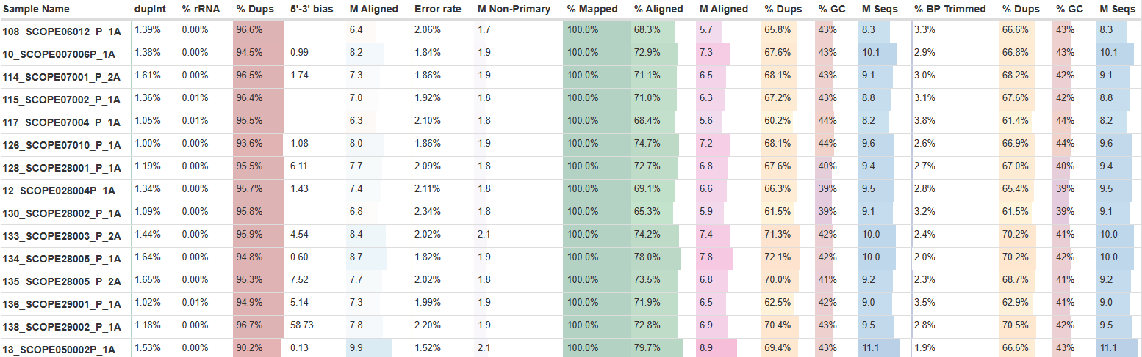
Table 2- Example of QC results

References

Published clinical results from the study:
- Crosby, T., Hurt, C., Falk, S. et al. Chemoradiotherapy with or without cetuximab in patients with oesophageal cancer (SCOPE1): a multicentre, phase 2/3 randomised trial. Lancet Oncol 14, 7, 627-637 (2013) https://doi.org/10.1016/S1470-2045(13)70136-0
Long term follow-up:
- Crosby, T., Hurt, C., Falk, S. et al. Long-term results and recurrence patterns from SCOPE-1: a phase II/III randomised trial of definitive chemoradiotherapy +/− cetuximab in oesophageal cancer. Br J Cancer 116, 709–716 (2017). https://doi.org/10.1038/bjc.2017.21

