**Modulating the Colorectal Cancer Extracellular Matrix to Promote T-cell Infiltration and Sensitise to Immunotherapy**

**Alex Gordon-Weeks**

**Consultant Hepatobiliary Surgeon and Clinical Lecturer**

**Background.**

Colorectal cancer (CRC) sensitive to immune checkpoint blockade (ICB) has an excellent outcome, but less than 15% of CRCs are sensitive. Re-modelling the tumour microenvironment is a potential means to improve sensitivity. Tumours with excessive extracellular matrix (ECM) deposition and an absence of intra-tumoural T-cells (Consensus Molecular Subtype, CMS4) are particularly insensitive to ICB and have a dismal outcome. TGFβ signalling is a defining feature of CMS4 CRC and a major regulator of the cancer ECM, having been postulated to drive stromal activation and immune evasion, positioning it as a target for ICB sensitisation. However, because TGFβ is a pleotropic cytokine, targeting ECM regulators downstream of TGFβ may provide greater therapeutic precision.

In healthy tissues, the ECM provides guidance signals that traffic immune cells through the stroma(1). Immune cells interact with fibrillar collagens in the ECM through discoidin domain(2) and integrin receptors(3) from which they receive activation cues. Because CMS4 CRCs display excessive ECM gene expression, this raises the possibility that these tumours utilise abnormal ECM deposition to selectively regulate movement of T-cells and immunosuppressive myeloid cells, effectively partitioning tumour immunity and providing a barrier between T-cells and the evolving mutant epithelium. In support of this concept, inverse correlation between collagen fibre abundance and T-cell number has been documented in breast(4) and pancreatic cancer(5) and inhibition of collagen deposition and cross-linking improved T-cell infiltration and sensitised murine breast cancers to ICB(4).

This project investigates whether ECM structure and composition is CRC subtype and mutation-dependent through analysis of ECMs in genetically modified mouse models (GEMMs) and those produced by cultured fibroblasts activated by CRC cell lines and epithelial organoids harbouring different mutations. Subsequently, ECM structure will be manipulated in-vitro to study its effect on ECM-mediated immune cell motility and activation. This will provide novel mechanistic data with a view to the identification of therapeutic targets within the ECM to promote T-cell infiltration.

**Preliminary Data.**

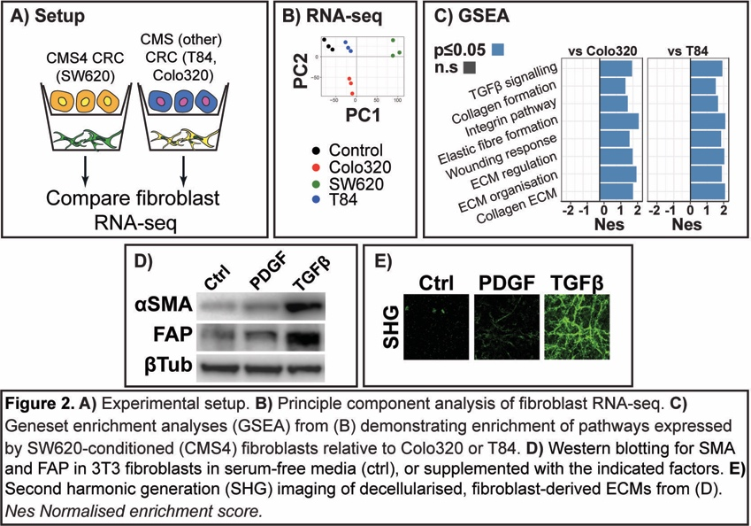To investigate whether the CRC epithelium regulates ECM structure in a CMS-dependent fashion, fibroblast transcriptome and ECM structure was assessed in fibroblast-CRC co-cultures using CRC cell lines of specified CMS type (Fig 2A)(6). CRC cell line CMS type differentially regulated gene expression in fibroblasts (Fig 2B). The CMS4 line SW620 induced Transforming Growth Factor-β (TGFβ) signalling and collagen deposition and remodelling programs when compared to non-CMS4 lines (Fig 2C). T84 cells are CMS2 typed and the Colo320 line is of neuroendocrine subtype(6)(7). TGFβ caused fibroblast activation (Fig 2D) and promoted ECM production (Fig 2E-F). These preliminary findings demonstrate that fibroblasts turn on transcriptional programs responsible for ECM production in response to co-culture with CMS4 cell lines and that fibroblast-derived ECMs can be visualised in culture. These techniques will be used to further investigate the relationship between epithelial mutation, ECM structure and immune motility/activity.

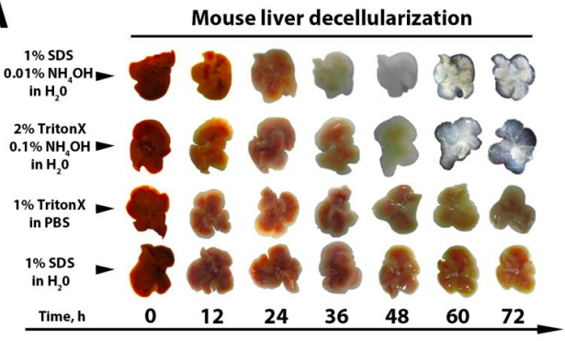

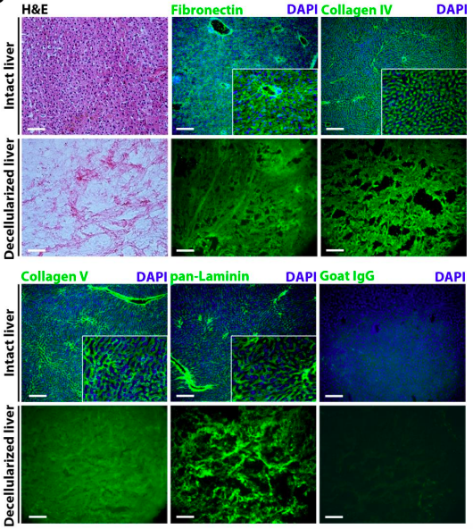

**Figure 2**. **Optimisation of a method to enrich for ECM proteins prior to proteomic assessment**. Whole murine livers with or without hepatic metastases were de-cellularised in the indicated solutions over a 72-hour period (left). Livers were most efficiently de-cellularised with a combination of 2% Triton X and 0.1% NH2OH. This enabled complete removal of cellular constituents as indicated by H&E staining but maintenance of ECM structure (right).

In a separate set of previously published experiments(8), we optimised a biochemical method for the de-cellularisation of murine liver and liver metastases from CRC (Fig 2). This technique preserve ECM architecture and enabled enrichment of ECM over cellular proteins; a process crucial for proteomic assessment of the ECM protein fraction. This technique will be used further in the proposed project.

**Proposed Experiments.**

***Phase 1. Does CRC mutation shape fibroblast-derived ECM composition?***

The applicant will study relationships between epithelial mutation and CRC ECM composition through expansion of the results presented in Fig. 1 and assessment of CRC-associated ECMs in genetically engineered mouse models (GEMMs). Data from Fig 1 will be extended to include a broader range of CRC cell lines of known mutation and MSI status as well as human colonic epithelial organoids carrying CRISPR-mediated knock-in KRAS, p53 and/or APC mutations. Co-culture derived ECMs are then de-cellularised and the resultant ECM protein scaffold is solubilised before undergoing proteomic assessment through liquid-chromatography mass-spectrometry (LC-MS)(Benedikt Kessler laboratory). We have extensive prior experience in the preparation of ECM proteins for LC-MS (Fig 2)(8)(9).

The applicant will then obtain primary and metastatic tumours from the GEMMs. The GEMMs develop spontaneous CRC on the background of compound mutation in APC, KRAS, p53 and/or TGFBR2. Various combinations of these mutations lead to CRCs recapitulating those seen in human disease and matching the various tumour types seen in the CMS system(10). The tumours will be de-cellularised and processed through the proteomics pipeline as above.

The primary outcome of interest is difference in ECM protein abundance with mutation status as the independent variable. Results from these experiments will indicate whether specific epithelial mutations force the generation of unique ECM compositions through fibroblast activation as would be in support of the preliminary data presented in Figure 1.

***Phase 2. What is the relevance of ECM composition to immune cell motility and function?***

The applicant will use de-cellularised ECMs generated in phase 1 as scaffolds on which to study immune cell migration and activation. Fluorescently labelled immune cell motility assessed with live cell imaging is compared on different ECMs. At this point, fibroblast lines lacking specific ECM proteins of interest from phase 1 may be generated through CRISPR-KO or pharmacological agents targeting ECM regulatory proteins (again identified through proteomics from phase 1).

***Phase 3. What is the spatial relationship between ECM components and the CRC immune infiltrate and how does epithelial mutation regulate this?***

Following identification of relevant proteins within the ECM, the applicant will optimise an ECM antibody panel for use alongside already optimised immune cell panels (lymphoid and myeloid cell types). The antibody panels will then be used to perform multiplexed immunohistochemistry on human primary and metastatic CRC specimens of known mutation, MSS and CMS type

**Training Opportunities and Required Experience.**

A good grounding in cell culture techniques will be required. De-cellularisation and subsequent preparation of ECM protein scaffolds for LC-MS will require some knowledge of biochemistry but can be taught in the supervising laboratory. The applicant will be encouraged to develop the bioinformatic skills required to analyse the generated data inclusive of proteomics and multiplexed immunohistochemistry although again training in this will be required. Although the project requires analysis of murine tissues, no animal handling will be required.