The role of immune-modulation in the anti-cancer activity of histone deacetylase inhibitor-based drugs in colorectal cancer – Dr Geng Liu and Prof. Nick La Thangue

Research Interests
An underpinning theme of our studies is that we believe, in order to design better therapies that effectively treat cancer, it is essential to decipher the molecular and biological details of pathways that control proliferation in normal cells and thereafter understand how they become aberrant in cancer.
We believe that biological knowledge on the mechanisms which drive cancer cell proliferation can be harnessed in designing new therapeutic modalities to treat cancer. Consequently, we work closely with the bio-technology and pharmaceutical sectors, together with clinical colleagues in translating our academic discoveries into an applied clinical setting. Drugs emanating from our earlier studies have been approved for haematological malignancy.
A major focus of our current work is to develop technologies that enable predictive biomarkers to be identified for cancer therapies. We have devised a genome-wide loss-of-function screen that identifies predictive biomarkers and deployed the platform to develop companion diagnostic tests for diverse cancer drugs.

Project
Lysine acetylation occurs on many proteins and therefore influences pathways with diverse functional roles (1). Significantly, aberrant protein acetylation is strongly linked to tumourigenesis (2), and modulating acetylation through targeting histone deacetylase (HDAC) with small molecule inhibitors has been the focus of clinical trials (3). However, clinical success on solid cancers, like colorectal cancer (CRC), has been limited, in part because the cancer-relevant mechanisms through which HDAC inhibitors act remain largely unknown (4, 5).
CXD101 is a promising second-generation inhibitor with selective activity towards HDAC class 1 subunits (6). It is a potent anti-proliferative agent which in human clinical studies demonstrated a favourable safety profile (6). In addition, encouraging and durable disease activity was seen in a Phase I clinical trial in patients with T-cell lymphoma, follicular lymphoma and Hodgkin lymphoma (including post-allogenic stem cell transplantation), with tumour reduction evident in 63% of patients (6). Although efficacious in haematological malignancy, we now want to develop a scientific understanding which supports a clinical rationale for deploying CXD101 in the solid cancer setting.
We have conducted a genome-wide expression analysis by RNAseq on human colorectal cancer cells, which identified a diverse set of differentially expressed genes (DEGs) upon treatment with CXD101. Functional profiling of the data set highlighted biologically enriched concepts related to immune recognition, specifically antigen presentation (AP) (Fig.1A) and natural killer (NK) cell activity (Fig.1B). A key objective of the present study is to leverage these early yet provocative results and gather an understanding of how the immune system is relevant to the anti-cancer activity of HDAC inhibitors. The study proposal will encompass the following steps:
1. Gene expression in human CRC cells: DEGs identified through bioinformatics on RNAseq will be confirmed by validating the RNA expression at the single gene level in CRC cells treated with CXD101 and related inhibitors. Our focus will be on genes that fall within the AP and NK biological concepts (1-2 month).
2. Gene expression in murine CRC tumour models: We will investigate the effect of CXD101 in the murine syngeneic colon26 tumour model, and perform RNAseq to study gene expression in the tumour micro-environment (TME) and assess the impact of CXD101 treatment. Bioinformatics analysis of the RNAseq data set will focus on biological concepts that involve immune-relevant gene expression and the effect of CXD101 treatment (6 months).
3. Analysis of the TME: The changes that occur in the population of tumour-infiltrating lymphocytes and other immune relevant cells upon CXD101 treatment, will also undergo detailed examination using digital pathology. The aim here will be to align changes gene expression level caused by CXD101 treatment with coincidental alteration in lymphocyte populations in the TME (3 months).
4. Drug combinations in CRC tumour models: The ultimate question we want to address is whether we can devise new clinical strategies based on a deep understanding of HDAC inhibitor biology. We will be guided by results but our scientific intent will be ask whether CXD101 effectively combines with anti-cancer agents that act through the immune system, like immune checkpoint inhibitor anti-PD1. Colon26 is an excellent mouse model to address this question as it is established to be poorly responsive to anti-PD1. RNAseq and follow-up bioinformatics will be performed on the combination therapy treated mice to address the impact on gene expression with further analysis on the TME (3 months).

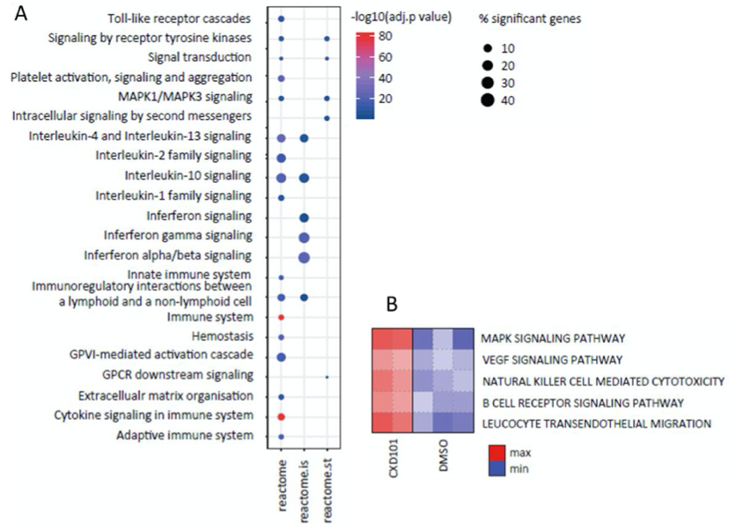
Our study seeks to perform a deep dive into recent results suggesting that HDAC inhibitors have a significant impact on the immune system. We believe that the results emanating from the study will have important translational potential for treating human malignancies like CRC, by illuminating novel drug combination therapies. We believe, given the strengths of University of Oxford and Sichuan University Huaxi joint Centre for Gastrointestinal Cancer, that this proposal could develop into a larger scale long term collaborative programme that leverages some of the very significant opportunities and synergies provided by Oxford and Sichuan.
Figure 1. Genome-wide analysis on CXD101 treated CRC cells. A) Enrichment of Reactome pathway descripters and specifically Reactome Super-Pathways, associated with the immune system (AP) and cytokine signalling in the immune system. B) Enrichment of several immune-related KEGG concepts, including natural killer (NK) cell mediated cytotoxicity.

