Mechanisms and consequences of MHC class I & II dysregulation in colorectal cancer - Dr. David Church

Research Interests
Our research focuses on the identification, functional characterisation, and clinical implementation of biomarkers in colorectal and endometrial cancer, with particular focus on those that relate to hyper/ultramutation and the antitumour immune response. Our work ranges from focused mechanistic analysis of cell and mouse models, to detailed characterisation of human tumours and broader study of large sample sets. The latter include the Genomics England cohorts of whole genome sequencing from colorectal cancer (2,500 cases) and endometrial cancer (750 cases), and samples from clinical trials (QUASAR2 – 1,200 cases; SCOT – 2,800 cases). Our group comprises a mix of wet and dry lab, with 5 postdocs, 5 students, and a research assistant.

Project
A large and expanding body of evidence indicates that the antitumour immune response plays a critical role in the development and clinical outcome of colorectal cancer (CRC). Much work has focused on the density tumour-infiltrating cytotoxic CD8⁺T cells, which we and others have shown is strongly associated with risk of recurrence in early-stage disease. In keeping with a selective pressure for cancers to escape immune surveillance, cancers frequently acquire defects in the MHC class I presentation pathway, leading to a failure to present antigen to CD8+ T cells. According to current understanding, this should allow the cancer to grow unrestricted; however several lines of evidence indicate that the interaction between tumour and immune system is vastly more complicated. These include:
- the fact that loss of B2M – an essential component of the HLA-class I complex –seems to predict better outcome in DNA mismatch repair deficient (MMRd) cancers in which it frequently occurs (PMID: 22353804, PMID: 31062389)
- the fact that CRCs with biallelic B2M loss can still obtain complete response to immune checkpoint inhibition (PMID: 32251400)
- the observations that expression of HLA (MHC) class II occurs in ~20% of CRCs (PMID: 24563618), and that loss of function mutations in genes that upregulate MHC class II expression are common in MMRd CRCs (PMID: 20013806)
- the strong association of intratumoral CD4+ T helper cells with improved outcome in colorectal cancer (PMID: 31488881)
In this pilot study, we will combine correlative and functional analyses to define the frequency, mechanisms and consequences of HLA class I and class II dysregulation in CRC. Our anticipation is that the data we generate will be used to support subsequent funding application to support a broader collaborative CRC immunoprofiling project between Oxford and Sichuan. The project objectives are as follows:
- to define the frequency of HLA class I and II dysregulation in CRC using cases from from the QUASAR2 and SCOT trials
- to determine the relationship between HLA class I and II dysregulation and clinicopathological and molecular variables, immune infiltrate, and clinical outcome in these cases
- to use cell models to define the mechanistic basis and therapeutic opportunities of HLA class I and II dysregulation in CRC
Plan of work
1. Frequency of HLA class I and II dysregulation
Following optimisation (in progress – fig 1A,B) tissue microarrays (TMAs) for the QUASAR2 and SCOT trial will be stained for HLA class I and II expression by co-immunofluorescence or immunohistochemistry. AI-based automated image analysis and quantification will be performed in collaboration with Viktor Koelzer (University of Zurich) under an existing collaboration.

2. Correlation of HLA class I and II dysregulation with patient and tumour factors and clinical outcome
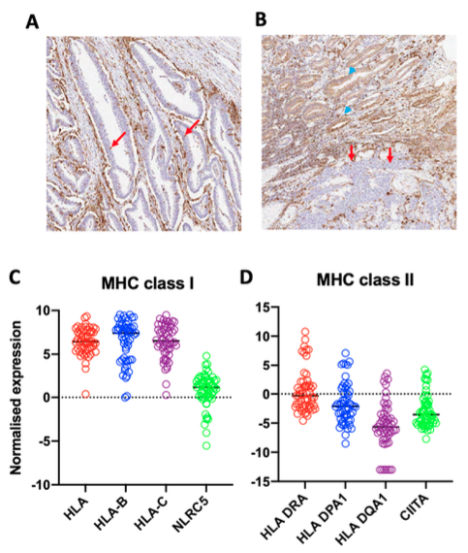
The frequency of HLA class I and II upregulation and loss will be correlated with demographic and clinicopathological variables (age stage etc.), molecular factors (MMRd status, KRAS, BRAF mutation) by standard statistical methods. The relationship with tumour recurrence and overall survival will be tested by Cox proportional hazards models, both in univariable analysis and after adjustment for confounders by multivariable analysis.

3. Mechanistic basis for HLA class I and II dysregulation in CRC
Preliminary analysis of CRC cell lines from the Cancer Cell Line Encyclopaedia indicates that >10% have dysregulation of HLA class I or II expression even in the absence of the IFN-g stimulation that occurs in vivo (fig 1C,D). This observation will be confirmed and extended by determining basal mRNA expression and protein levels of HLA class I and II and related (e.g. B2M, NLRC5, CIITA etc) molecules in our CRC cell line panel by RNAseq and immunoblot. These analyses will be repeated following IFN-g stimulation in a subset of lines with and without evidence of dysregulation. Results will be correlated with the (epi)mutational status of HLA and regulatory molecules (whole exome sequencing and methylation data available). Results will be correlated with those from similar studies in other tumour types (PMID: 15814633) and from #1 and #2 above. Where possible, novel mechanisms of dysregulation will be examined in the trial samples, though this will likely be in follow-up studies given the time frame of this attachment.
Fig 1. HLA class I and II dysregulation in colorectal cancer. Pilot immunohistochemistry for HLA-DR in two CRC samples, one showing absent epithelial expression (red arrows) (A), another showing heterogeneous signal with areas of expression (blue arrowheads) and loss (red arrows) (B). mRNA expression of HLA class I genes and master regulator NLRC5 (C) and class II genes plus master regulator CIITA in colorectal cell lines (i.e. epithelial-specific expression)

Outputs
- Definitive analysis of the frequency of HLA class I and II dysregulation in CRC
- Comprehensive analysis of the clinical, molecular and immunological correlates of HLA class I and II dysregulation
- in CRC
- High-quality evidence for the value of HLA class I and II dysregulation CRC as a prognostic marker
- Definition of the mechanisms by which HLA class I and II molecules are dysregulated in CRC, with potential
- therapeutic relevance
- Results for conference presentation and peer-reviewed publication
- Preliminary data to support subsequent substantive funding application and Oxford-Sichuan collaboration for
- broader CRC immunoprofiling in retrospective and prospective cohorts
- Valuable experience for talented Sichuan postdoc to spend time in a leading Oxford research institute (WHG)

