Modelling stroma-epithelium communication in the healthy and in the tumorous gastric mucosa – Dr. Francesco Boccellato

Research Interests

The human gastrointestinal tract is home for numerous bacteria, some of which are pathogenic and are found associated with the onset of adenocarcinomas. Our lab is interested in understanding the contribution of microbial infection to human cancers. Our approach is to develop advance stem-cell-driven culture models to study epithelial homeostasis and response to infections. We think that a better understanding of the epithelium in the healthy mucosa reveals new insights into the molecular mechanisms that poses an infected epithelium at risk of malignant transformation.

Project

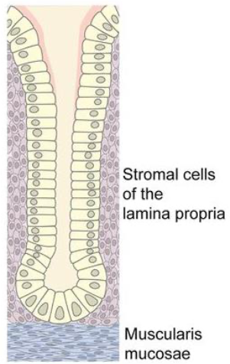
The mucous membrane that covers the stomach is characterised by deep invaginations in the lining called glands. The glands are made of an epithelial monolayer supported by the stroma of the lamina propria and of the muscularis mucosa (Figure 1). Both type of stroma are made of fibroblast of mesenchymal origin and they form the scaffold of the glandular epithelium. Besides a structural role, the stroma provides signals to the epithelium regulating different biological functions including stem cells maintenance and cell differentiation. In the healthy mucosa for example it is known that WNT pathway activation is essential for stem cell maintenance and it has been found that the muscularis mucosa is a source of WNT agonist such as Rspo3 [1]. The stroma of the lamina propria instead induces cell differentiation probably through the secretion of soluble WNT inhibitors [2].

Acid reflux, tobacco smoke and infection with Helicobacter pylori are the main risk factors for the development of gastric adenocarcinoma a cancer that originates from the gland epithelium. Gastric cancer accounts for 3% of cancer deaths in the UK but the rate rises to 13% in China, where this cancer is the third for mortality among all tumours. Also the cancerous tissue is supported by a stromal component which provides growth factors to the transformed cells. This stromal component is mostly made by cancer associated fibroblast. Altogether these initial findings support the notion that the stroma is able to shape the epithelium in health and in cancer condition.

The regulation of the expression of the growth factor in the stroma is still not understood. Signals coming from the epithelium or from cell of the immune system might induce a response in the fibroblasts which in turn signals back to the epithelium. Studying this multilateral signals will improve our understanding of the gland microenvironment and it might explain how the stroma might contribute to disease progression toward cancer.
Figure 1: a schematic of a gastric gland showing the columnar epithelium (in yellow) and the surrounding stroma.

The study of the stroma-epithelium interaction in human tissue is limited by the lack of experimental models. If single-cell RNA sequencing technology is a promising tool to characterise the different stromal cells and their gene expression in different conditions (e.g. normal mucosa vs cancer) we still need an advanced in-vitro model where conditions and parameters can be tightly controlled.

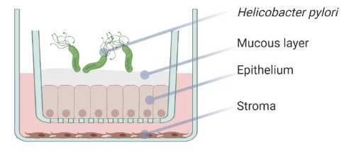
We have recently developed a stem-cell driven culture of healthy human epithelial cells for the stomach. Cells in the culture are capable of multi-lineage differentiation and they even produce mucus on the apical side. These cultures are called “Mucosoids”. Fibroblast from the same tissue origin of the epithelium can also be isolated and cultivated. The co-cultivation of the fibroblast with the epithelium is a useful resource to study the complex communication network between these two types of cells.
Figure 2: A schematic of an infected mucosoid culture: the epithelium is cultivated on a porous filter in a transwell in Air-Liquid-Interface. The epithelium of the mucosoid produces apical mucin. Infection with Helicobacter pylori can be performed by adding the bacteria on the apical side. The stroma can be cultivated on the bottom of the plate in close proximity but not in contact with the epithelium

Our plan is to use this co-culture system of the mucosoid to understand the communication between the healthy or the cancerous epithelium with the stroma and in particular to understand the role of stroma in orchestrating regeneration and response to infection. We plan to isolate epithelial and stromal cells from the normal and from the cancerous epithelium and we plan to stimulate them with pro-inflammatory cytokines and infection with Helicobacter pylori. We will analyse the activation of signalling pathways of the epithelial cells using mucosoids in single and in co-culture.

The overarching goal of this project is to build a map of the interactions between the stromal and the epithelial compartment to understand the role of the stroma in supporting gastric tumorigenesis. This project falls within the remit of the Oxford Cancer Centre in understanding GI cancer microenvironment and the epithelial stromal interaction (Theme 3). Using our model system we will identify potential signalling pathways regulating the regenerative and the inflammatory response of the normal and of the cancer epithelium. A subsequent step is to map ligands and receptors back in the original tissue by using biopsies and tumour resections from different stages of the gastric carcinogenic cascade. The cell culture technology developed in Oxford and the large collection of gastric cancers and precancerous conditions samples of West China Hospital are the ideal settings for a successful completion of this project.

